DIVINE SECONDARY SCHOOL KITALA

BEGINNING OF TERM TWO EXAMS 2024

S.4 CHEMISTRY

TIME : 2 HOURS

NAME…………………………………………………………………………………SIGN………………………..

LIN…………………………………………………………………………………………………………………….

INSTRUCTIONS TO CANDIDATES

ANSWER ALL ITEMS

1. Agroupofstudentsfoundoutthatdifferentmetalsreactdifferently.They observed this when some metals were made to react with cold water and steam. The changes they observed are summarized in the table below.

|  |  |  |
| --- | --- | --- |
| Metal | Reactionwithwater | Reactionwithsteam |
| Sodium | Reacts rapidly | Reacts violently |
| Calcium | Slowreaction | Fast reaction |
| Copper | No reaction | No reaction |
| Magnesium | Veryslowly | Relativelyfast |
| Iron | Too slow | Slow |

* 1. Usetheinformationinthetabletoarrangethegivenmetalsstartingwiththe most reactive to the least reactive
  2. Explainifcalciumcouldbesuitableformakingroofing sheets
  3. Whichofthemetalswouldbemostsuitablefor useinmakingwaterpipes?

1. 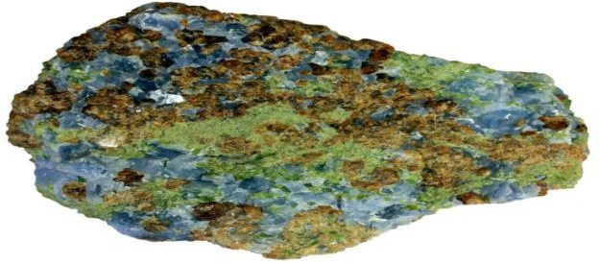ThefigurebelowshowsasampleofametamorphicrockobtainedfromKilembe mines.
2. Nametwoobservable featuresoftherocksample.
3. Thesamplewasanalyzedandfoundtocontain51.6%copper,9.7%carbonand the rest oxygen.
   1. CalculatethepercentagecompositionofOxygenintherock sample.
   2. Whatistheempiricalformulaofthecopper compoundintherocksample? (Cu=64, C=12, O=16)
   3. Ifthemolecularmassofthecopper compoundfromtherocksampleis124, what is its molecular formula?
4. 6.2gofthecoppercompound in(b)abovewasheatedstronglytoconstant mass.
   1. Writeequationforthechangethattookplaceduringheating.
   2. Calculatethevolumeofthegaseousproductformedatstp. ( molar gas volume= 22.4dm3 at stp)
   3. Calculatethechangeinmassofthecoppercompound.)
5. Below is an article extracted from the New Visionof07th / May/2022.The website to which it was downloaded has been provided at the end ofthearticle.Readthearticlecarefullyandanswerthequestionsthatfollow.**TOPSTORY**

‘’Air pollution killing more than HIV’’ -New vision official**.GeraldTenywa.Journalist @NewVision.**

Every home in Uganda has either been infected or affected by HIV andAIDS. They have either lost a relative or have suffered as a loss of a breadwinner.Air pollution has gone steps ahead ofHIV in affecting Ugandansas it has claimed more lives than HIV, Daniel Okello , the director incharge of environment at Kampala Capital City Authority (KCCA), hassaid.“Welost23,000Peoplein2019 dueto HIVin Uganda.In thesame

period, 26000 People died as a result of cardiovascular diseases linked toair pollution,” he said. Okello was speaking during the launch of the airquality awareness week at the Uganda Media Centre in Kampala on 4May2022.

The event, **themed** “Be air aware, be prepared" ,attracted top officialsfrom the National Environment Management Authority( NEMA),MakerereUniversityandMinistryofHealth,whocalledforincreasedawareness andactions tocurb air pollution.

Okello mentioned of two types of air pollution -outdoor pollution andhousehold or indoor pollution which are all greatest environmental threatto human health around country pointing out Kampala, Mukono and Jinjawith the poorest air quality which is five times way above the criticalthreshold of World HealthOrganisation.

Okellosaidindoorairpollutionresultingfromcookingwithbiomassfuelparticularly charcoal, firewood, coal ,burning of organic fuels such askerosene, burning of grass and waste products. Partial combustion ofthese fuelslead to emission of carbon monoxide gas, which is poisonousif inhaled. Worse than indoor air pollution, he added, is outdoor airpollution include old cars spewing fumes. Asthe cars burn fuels, such asdiesel and petrol to power engines, they release poisonous gases such ascarbon monoxide and also lead from motor vehicle emissions, dust fromunpaved roads and construction sites, factories release fumes filled withsulphur dioxide gas which leads to acid rains and carbon monoxide gaswhich is poisonous .Burning of wastes including plastics , producesdioxins andfurans,which cause cancer.

Dr Ivan kimuli from Makerere University’s lung institute said they havedone studies that indicate that 11% of the population suffers from asthmaand that was being aggravated by poor air qualityand the same studyindicated that children in rural settings had “ better and less damagedlungs"thanthoseinurbansettings,whowereexposedtopollutantsintheair.NEMA's director for environment monitoring and compliance,WaiswaAyazika,said:“the governmentiscurrentlymaking aclearplan

toimproveairqualityinvolving everybody's responsibilityto savethecurrent and future generation.”[**http://www.newvision.co.ug/category/health/air-pollution-killing-**](http://www.newvision.co.ug/category/health/air-pollution-killing-)**morepeople-than-hiv-133316**.

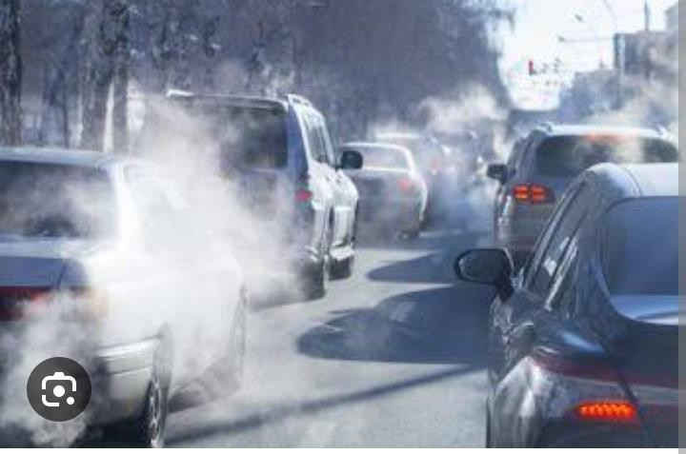

(a).Statewhat is meantbythe term“airpollution"? (02scores)

(b)From the article; state the different types of air pollution and outlinehoweachtypeofairpollution is caused. (08 scores)(c)From the article, state the main air pollutants and show their effects toman. (08 scores)

1. SuggestareasonwhyKampala,MukonoandJinjahavethepoorestairquality which is five times away above the critical threshold ofWorldHealthOrganisation? (02scores)
2. Suggest any 5 solutions that can be adopted into the government’sstrategicplan ofhowairpollutioninthecountrycanbegreatlyreduced

(05scores)

**END**